Lansing Area Breweries and Brewpubs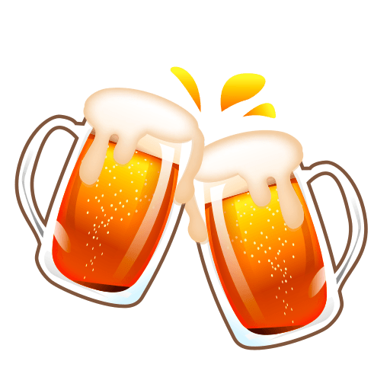

Eagle Monk Pub and Brewery
https://www.eaglemonkbrewing.com/
4906 W. Mt. Hope Hwy.
Lansing, MI 48917
517-708-7350
Open:
Tue. – Thu. 3:00 PM – 10:00 PM
Fri. & Sat. 12:00 Noon – 11:00 PM
Sun. – 12:00 Noon – 9:00 PM

Ellison Brewery and Spirits
4903 Dawn Avenue
East Lansing, MI 48823
http://www.ellisonbrewing.com/index.html
(517) 203-5498
Open:
Mon. & Tues. 3:00 – 10:00 PM
Wed. & Thu. 3:00 – 11:00 PM
Fri. & Sat. 12:00 Noon – 12:00 Midnight
Sun. 12:00 Noon – 8:00 PM

Harpers Restaurant and Brew
131 Albert Ave.
East Lansing, MI 48823
http://www.harpersbrewpub.com/
517-333-4040
Open:
Everyday 11:00 AM - 2:00 AM

Lansing Brewing Company
518 E. Shiawassee St.
Lansing, MI 48912
http://www.lansingbrewingcompany.com/
517-371-2600
Open:
Mon. – Thu. 11:00 AM – 11:00 PM
Fri. – Sat. 11:00 AM – 1:00 AM
Sun. 12:00 Noon– 10:00 PM

Midtown Brewing Company
402 South Washington
Lansing, MI 48933
http://www.midtownbrewingco.com/
517-977-1349
Open:
Mon. – Wed. 11:00 AM – 11:00 PM
Thu. – Sat. 11:00 AM – 1:00 AM
Sun. 11:00 AM – 10:00 PM

Old Nation Brewing Company
http://oldnationbrewing.com/
1500 W. Grand River Ave.
Williamston, MI 48895
517-655-1301
Open:
Sun. – Thu. 11:00 AM – 10:00 PM
Fri. – Sat. 11:00 AM – 12:00 Midnight

Ozone Brew House
305 Beaver St.
Lansing, MI 48906
http://www.ozonesbrewhouse.com/home.html
517-999-2739
Open:
Tue. – Thu. 4:00 PM – 10:00 PM
Fri. – Sat. 12:00 Noon – 12:00 Midnight
Sun. 1:00 PM – 8:00 PM

Spartan Brewpub
3056 Okemos Rd.
Mason, MI 48854
https://spartanbrewpub.com/
517-507-5098
Open:
Tue. – Thu. 3:00 PM – 10:00 PM
Fri. – Sat. 12:00 Noon – 11:00 PM
Sun. 12:00 Noon – 9:00 PM

